**Getter methods:**

Getter methods are methods used to get components of date object (day, month, year...) and appear it separately.

These methods are:

1. **getDay();**

This method is used to get number of a day within the week in local time.

Number of days is:

|  |  |
| --- | --- |
| **Day** | **Number** |
| Sun | 0 |
| Mon | 1 |
| Tue | 2 |
| Wed | 3 |
| Thu | 4 |
| Fri | 5 |
| Sat | 6 |

**Example 1:**

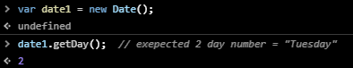

**Example 2:** if you need to return day name instead of day number use switch method**.**

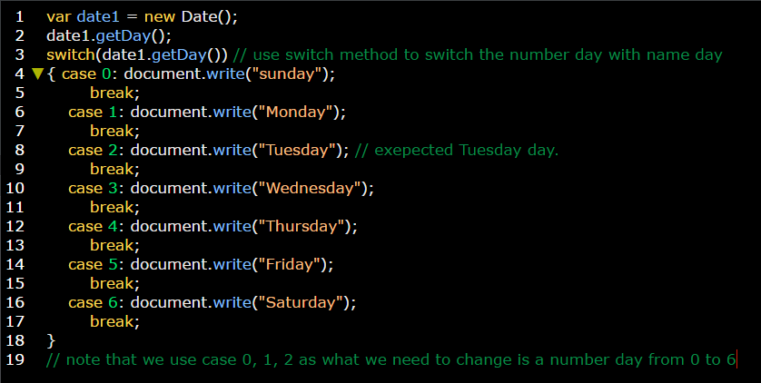

1. **getDate();**

This method is used to returns day number within the month (1:31).

**Example 1:**

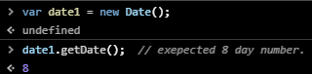

1. **getMonth();**

This method is used to get number of a Month within the year in local time.

Number of Months is:

|  |  |
| --- | --- |
| **Day** | **Number** |
| January | 0 |
| February | 1 |
| March | 2 |
| April | 3 |
| May | 4 |
| June | 5 |
| July | 6 |
| August | 7 |
| September | 8 |
| October | 9 |
| November | 10 |
| December | 11 |

**Example 1:**

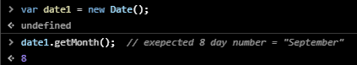

**Example 2:** if you need to return Month name instead of Month number use switch method**.**

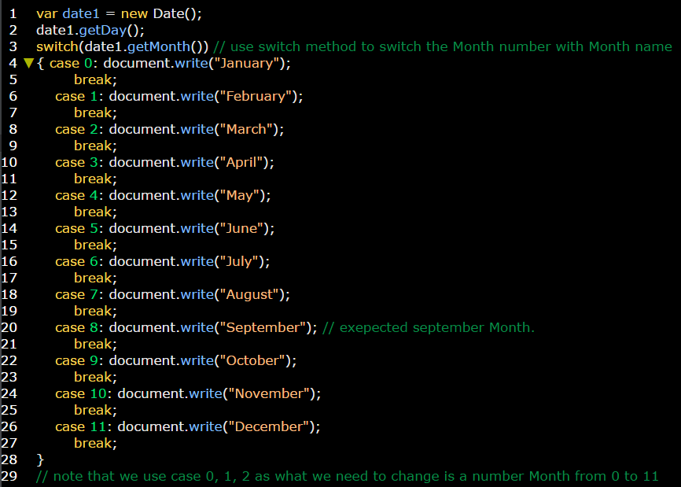

1. **getFullYear();**

This method is used to get the year in local time.

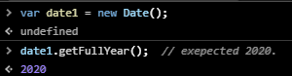

1. **getHours();**

This method is used to get day’s hour (0:23).

**Example 1:**

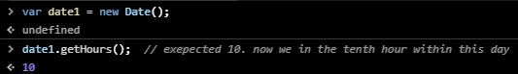

1. **getMinutes();**

This method is used to get hour’s Minutes (0:59).

**Example 1:**

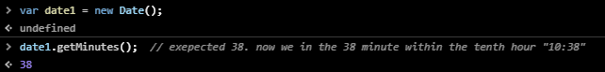

1. **getSeconds();**

This method is used to get minute’s seconds (0:59).

**Example 1:**

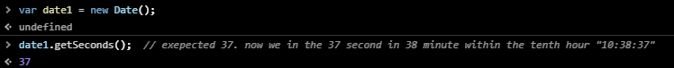

1. **getMilliseconds();**

This method is used to get second’s milliseconds (0:999).

**Note:** 1s = 1000ms

**Example 1:**



**UTC:** is used with all above methods to get the global / universal time.

**Example:**

